Instructions for Creating a Student Text Access Account

Go to the website: www.classzone.com. Click the “High School” circle for Language Arts; then click on the state of South Carolina; then click on “GO” under Find Your Book.

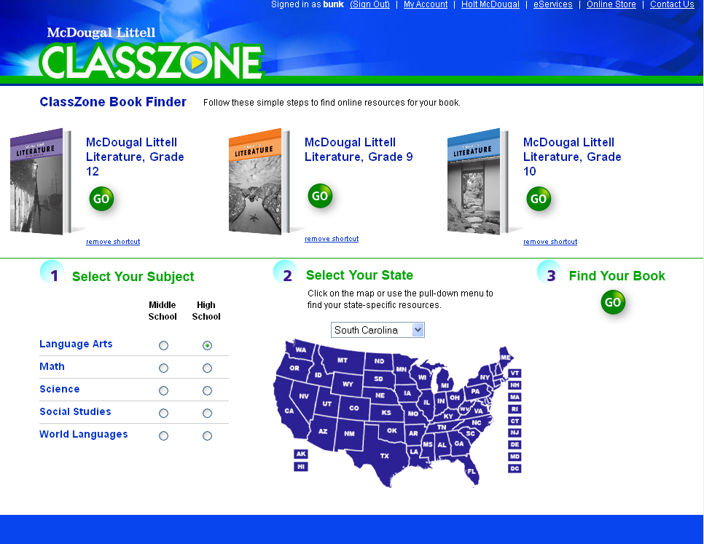

The next screen will offer a selection of available textbooks. Click on the first picture icon entitled “McDougal Littell Literature, Grade 12.”
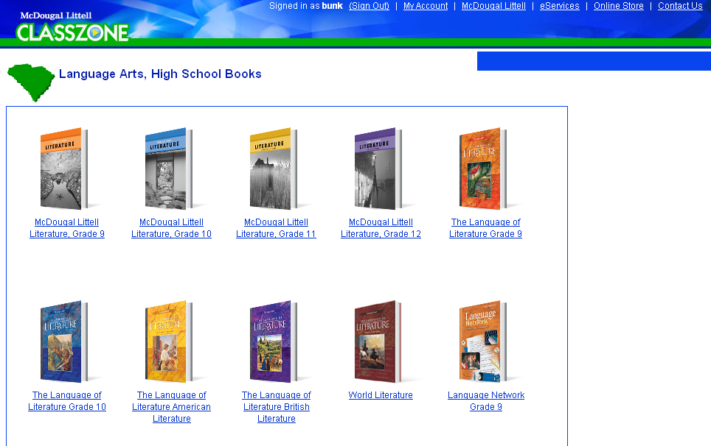

The next window offers many different links that you can access throughout the year. However, you will not have access to the link “Teacher’s Toolbox.” Continue by clicking on “Online Book” in the bottom left-hand corner.
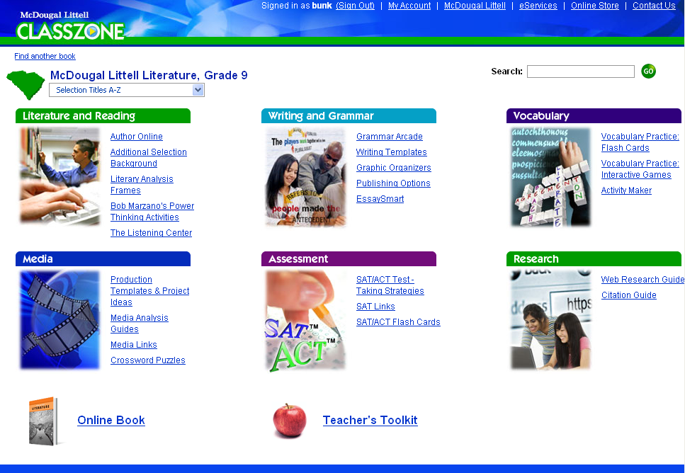

The next window allows you to create your student account. First, you must click on “Create a Student Account.” After completing this entire process, you will simply enter your Username and Password and clicking on “Submit” to access the Online Textbook.
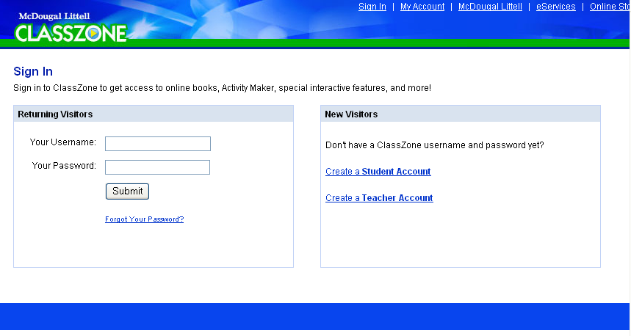

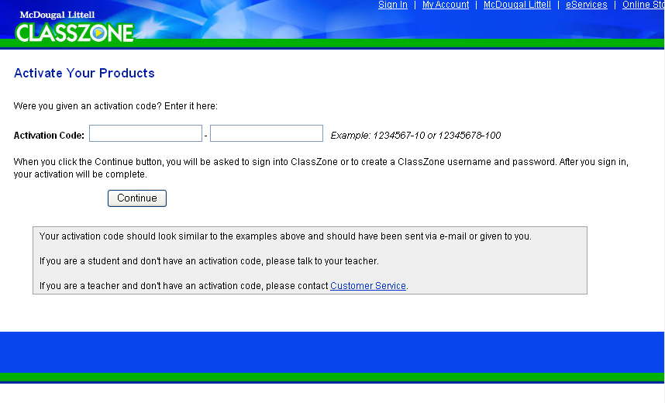
In the next window, you must type in information. In the first box following “Activation Code,” type in the following numbers: 3258542. Hit the Tab key to move the cursor into the next box; type in the following numbers: 40. Click on “Continue” to the next screen.

Enter your birthday information by using the pull-down bars for “month,” “day,” and “year.” Then click on “Continue.”
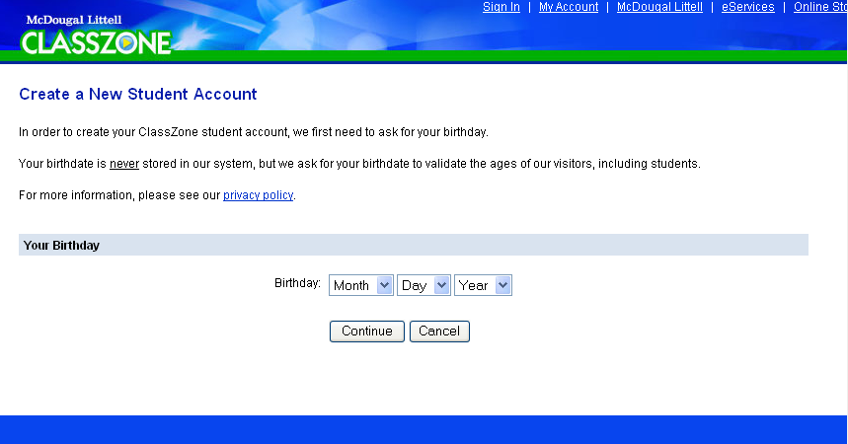

Complete the required information by typing in the next five boxes.
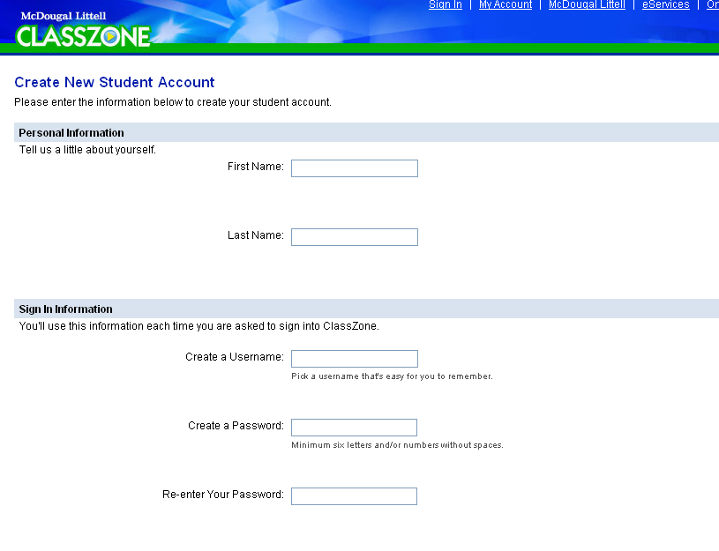

In the second half of the screen, finish completing the security information. You must check the “Terms and Conditions of Use” box before clicking on “Create Account.”
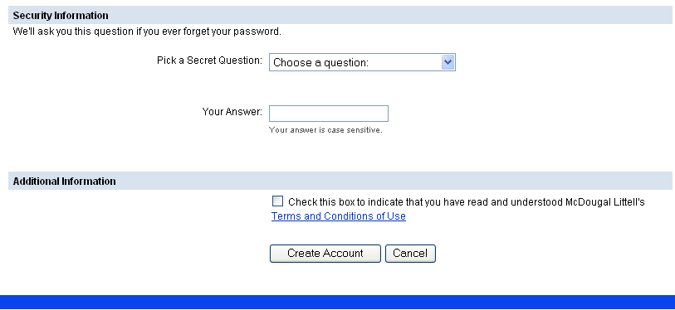

You will then see the screen showing your newly created Username and Security Question and that your registration is complete. Click on the “Go to Classzone” button.
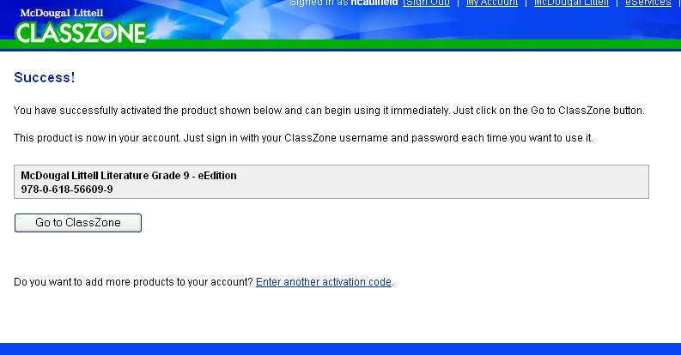

You will repeat the first three steps in order to get back to the “Online Book” link. You will now have access to the entire textbook contents. The next time you log onto the site, you will need to use the newly created Username and Password.

